1. Install and configure the necessary dependencies

sudo yum install -y curl policycoreutils-python openssh-server

sudo systemctl enable sshd

sudo systemctl start sshd

Check the OpenSSH status

sudo systemctl status sshd

It should be:

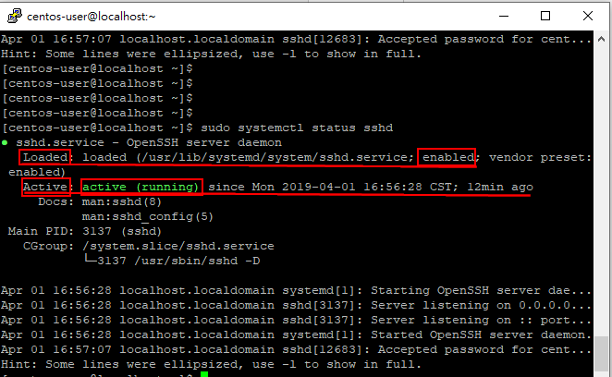

Configure the firewall

sudo firewall-cmd --permanent --add-service=http

sudo systemctl reload firewalld

Check the firewall status

sudo systemctl status firewalld

It should be:

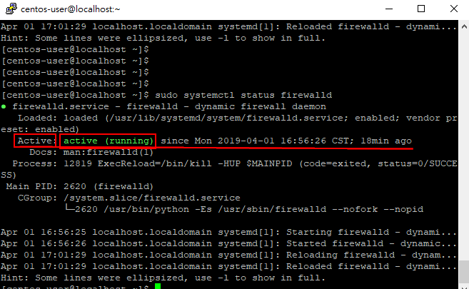

Check the firewall config

sudo firewall-cmd --list-all

It should be:

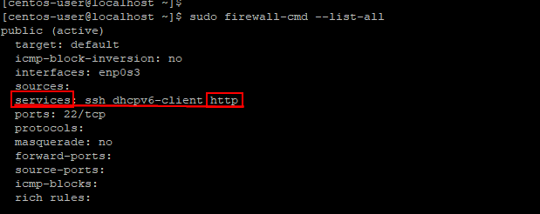

2. Install Postfix to send notification emails

sudo yum install postfix

sudo systemctl enable postfix

sudo systemctl start postfix

3. Add the GitLab package repository and install the package

Add the GitLab package repository

sudo curl https://packages.gitlab.com/install/repositories/gitlab/gitlab-ee/script.rpm.sh | sudo bash

Install the GitLab package

sudo EXTERNAL_URL="https://gitlab.example.com" yum install -y gitlab-ee

Change the URL & the port at which you want to access your GitLab instance

sudo vim /etc/gitlab/gitlab.rb

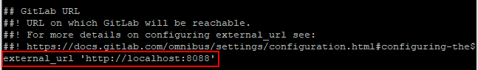

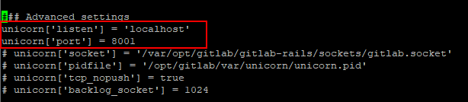

Reconfigure & Restart gitlab

sudo gitlab-ctl reconfigure

sudo gitlab-ctl restart

It should be:

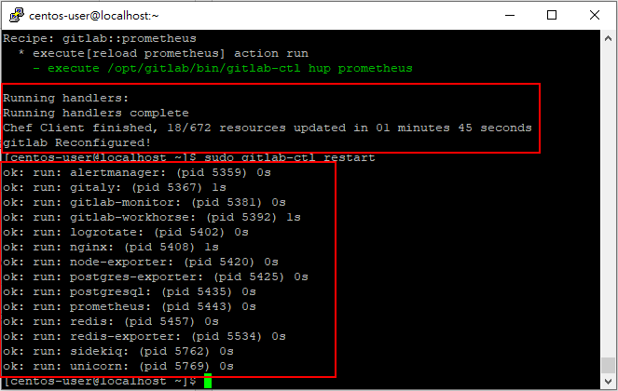

If you change the port at which you want to access your GitLab instance, then you need to configure the firewall for the new port like this

sudo firewall-cmd --permanent --zone=public --add-port=8088/tcp

sudo firewall-cmd --reload

And check the firewall config again

sudo firewall-cmd --list-all --permanent

It should be:

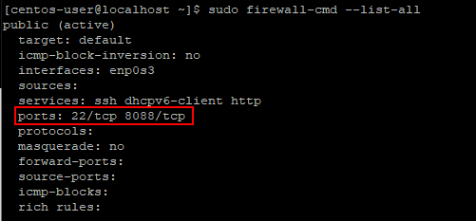

4. Browse to the hostname and login

Use the default account's username root to login

